# Experiment 5: ARQ Mechanisms in DLL

**Aim:** To implement receiver algorithms for the different ARQ mechanisms at the Data Link Layer

**Objective:** After carrying out this experiment, students will be able to:

* implement receiver algorithms for the different ARQ mechanisms at the Data Link Layer
* Analyze the differences between the ARQ mechanisms

**Problem statement:** You are required to write a program that can receive frames at the data link layer. Assume that the user is entering the frames as the transmitter. You are required to implement stop and wait, go back N and selective repeat ARQ mechanisms. Consider that you have to transmit and receive a total of 20 frames using WT=WR=1, WT=5 and WR=1 and WT=WR=5 for stop and wait, go back N and selective repeat respectively

**Analysis:** While analyzing your program, you are required to address the following points:

* Difference between stop and wait, go back N and selective repeat.
* Comparison of the disadvantages of the different ARQ mechanisms.

**MARKS DISTRIBUTION**

|  |  |  |
| --- | --- | --- |
| **Component** | **Maximum Marks** | **Marks Obtained** |
| Preparation of Document | 7 |  |
| Results | 7 |  |
| Viva | 6 |  |
| **Total** | **20** |  |

Submitted by: K Srikanth

Register No: 17ETCS002124

1. **Algorithm/Flowchart**

In the following algorithm, sender’s data is transmitted to receiver which has to acknowledge of its reception to the sender. Since we cannot simulate the situation in a single computer. A random number is generated on every iteration (while sending ‘I’th frame) and divided by 2, checking the remainder can help us evaluate two cases.

Case1: Remainder is 0: Interpreted as successful acknowledgement

Case2: Remainder is not zero: Interpreted as time-out and no acknowledgement, hence attempt for retransmission.

* + 1. Start
    2. Input total number of frames: N
    3. For I=0:N do
       1. Input ‘I’th Frame to be sent
       2. End for I
    4. For I=0:N do
       1. Generate a random number : rand()
       2. If ( rand()%2 ) do
          1. Copy from sender’s data buffer to receiver’s data buffer  (rdata[I]=sdata[I])
       3. Else
          1. I=I-1
          2. Retransmit
       4. Endif
    5. For I=0:N do
       1. Print rdata[I]
       2. End for I
    6. End

1. **Program**

**Stop and Wait**

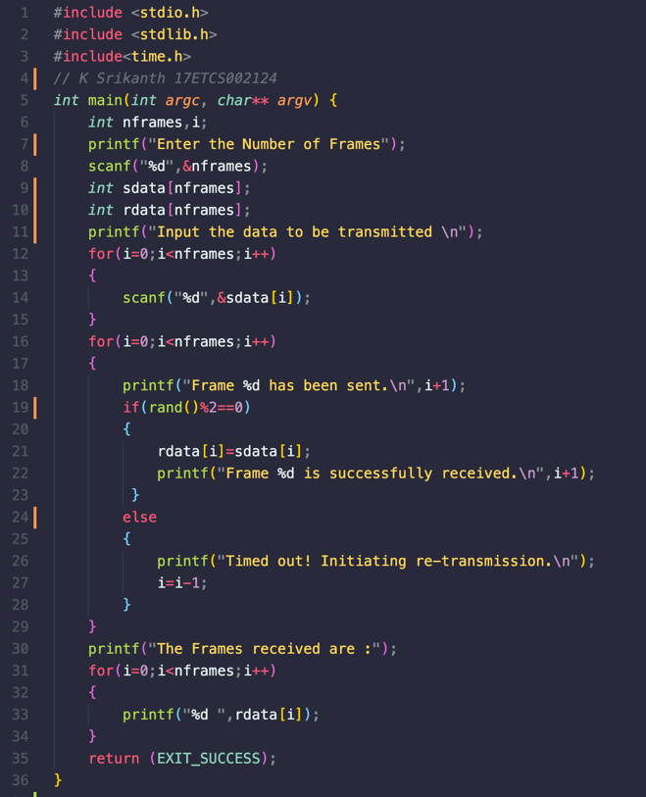

Figure 1 C Program for Stop and Wait Protocol

**Go Back N**

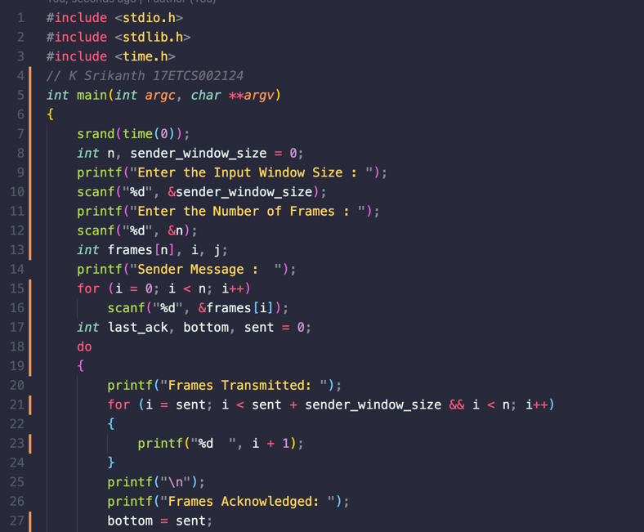

Figure 2 C Program for Go Back N Protocol

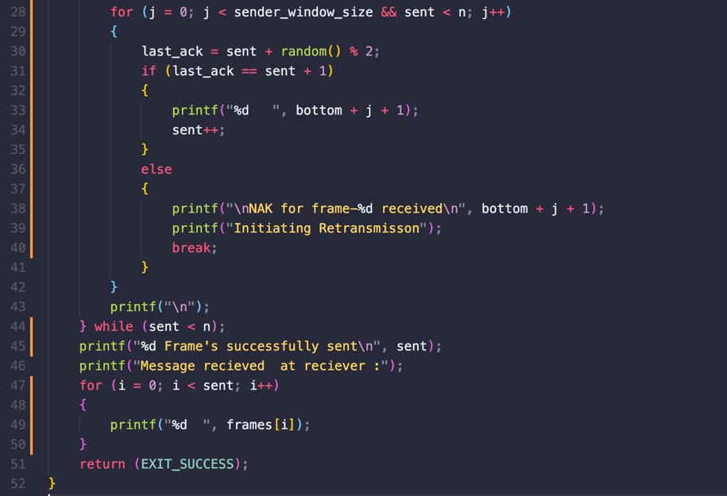

Figure 3 C Program for Go Back N Protocol Continued

**Selective Repeat**

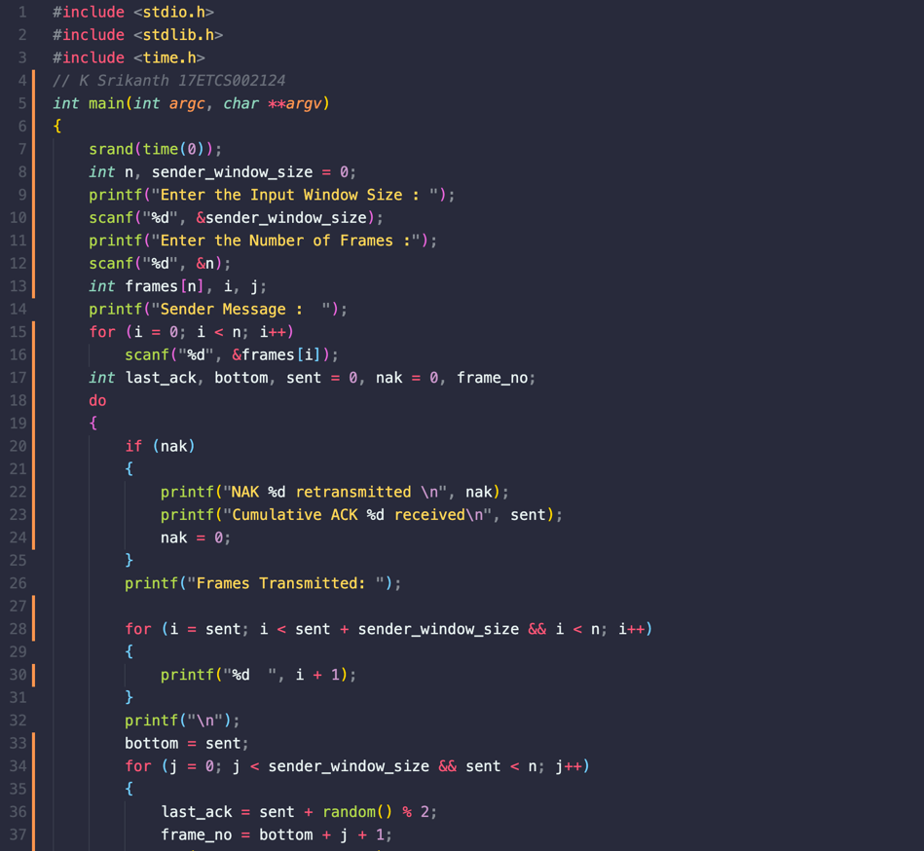

Figure 4 C Program for Selective Repeat Protocol

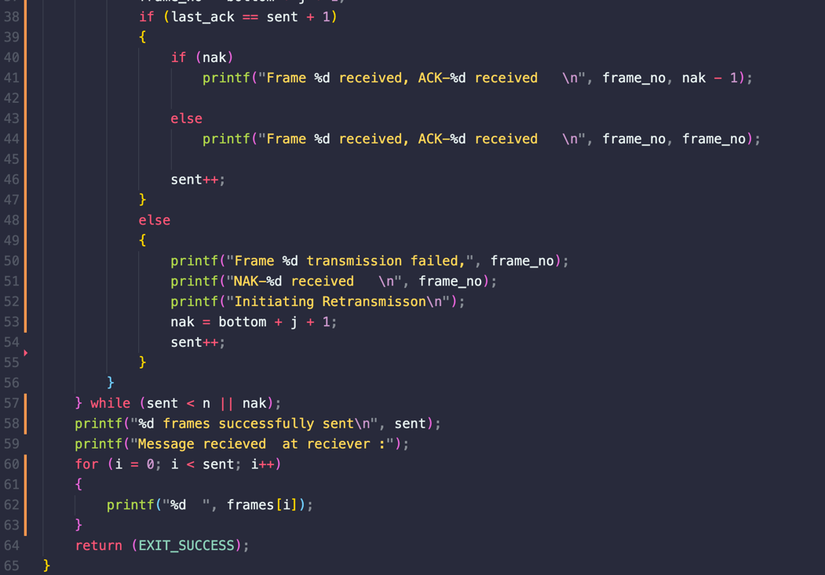

Figure 5 C Program for Selective Repeat Protocol Continued

1. **Results**

**Stop and Wait**

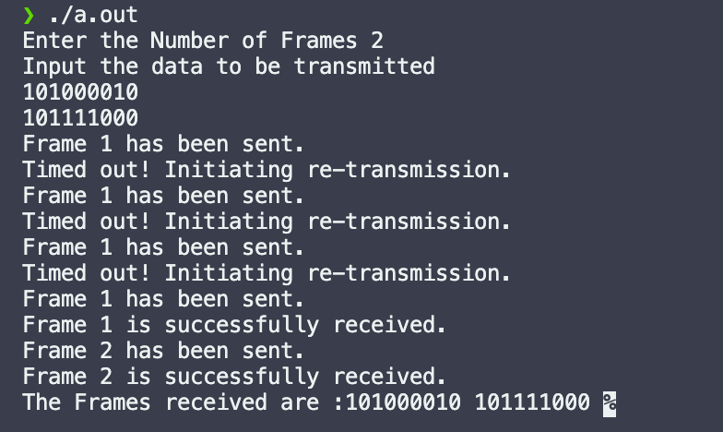

Figure 6 C Program Output for Stop and Wait Protocol

**Go Back N**

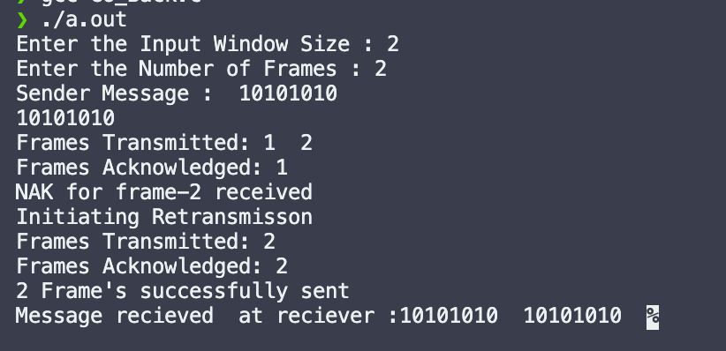

Figure 7 C Program Output for Go Back N Protocol

**Selective Repeat**

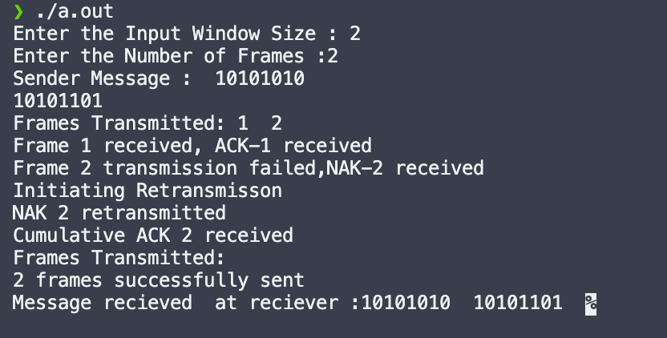

Figure 8 C Program Output for Selective Repeat Protocol

1. **Analysis and Discussions**
2. **Difference between stop and wait, go back N and selective repeat.**

The sliding window protocol is used to transmit frames and receive acknowledgement.

* In stop and wait protocol frames are sent one by one, and if negative or no

acknowledgement is received for a frame then the frame is retransmitted.

* Go back N sends a set of frames at once and the receiver sends acknowledgement one by one, suppose any frame in sliding window receives negative or no acknowledgment, frames are re-transmitted from that particular frame. This protocol just sees the recent frame that received acknowledgement and slides the window above it.
* Selective repeat sends the frames in a collection and receiver sends acknowledgements for the frames, the frames for which negative acknowledgement are (NAK) received are stored in a buffer and transmitted again later. When the receiver receives that frame again, it replies with a collective acknowledgement called cumulative acknowledgement, acknowledging the same and all that followed.

**2. Comparison of the disadvantages of the different ARQ mechanisms.**

The main difference between three lies between sender’s window size and receiver’s window size.

|  |  |  |
| --- | --- | --- |
|  | Sender’s size | Receiver’s size |
| Stop & wait | 1 | 1 |
| Go Back N | N | 1 |
| Selective repeat | N | M |

Comparison of the disadvantages of the different ARQ mechanisms.  ARQ mechanism of Stop & wait protocol introduces reasonable delay in transmission, as  it waits for acknowledgement of each frame. So it is not a good idea for it to be  implemented in case where there are large number of frames to be transmitted.

1. **Conclusions**

The above program successfully computes the Stop & wait protocol. In this method of flow control, the sender sends a single frame to receiver & waits for an acknowledgment. The main advantage of stop & wait protocols is its accuracy. Next frame is transmitted only when the first frame is acknowledged. So, there is no chance of frame being lost. However, its disadvantages outweigh its advantages.

1. **Comments**
   1. **Limitations of the experiment**

As considered, program doesn’t simulate the exact scenario, where sender and  receiver are setup on two different systems. It is just a single case here, while in  reality data is lost in different means. It can be no acknowledgement or negative  acknowledgement cannot be illustrated properly.

* 1. **Limitations of the results obtained**

Program ran for 20 frames, output considerably lengthy. So just presented  illustration for 7 frames.

* 1. **Learning**

Sliding window protocols, stop & wait protocol, go back N and selective repeat. its advantages and disadvantages.